What Goes Into the Encoder?
Only image tensor
X_img → Encoder (ResNet-50)
(B, 3, 224, 224)
Encoder output:
Memory M = (B, 1, 512)
This is a single image vector representing the entire picture.

🎯 2. What Goes Into the Decoder?
Only caption tokens
The decoder input is:
Caption_in = [<BOS>, w1, w2, ..., w_{T-1}]
Shape: (B, L-1)
The decoder uses:
- Its own token embeddings
- Its own positional encodings
- The encoder memory (image embedding)
NO metadata is involved.

🎯 3. Does image “multiply” with metadata?
❌ No. Nothing multiplies with metadata.
Because baseline uses NO metadata at all.
The decoder cross-attends only on:
Image Memory M (B, 1, 512)
Metadata is not processed, not embedded, not combined, and not used.

🎯 4. How do encoder output and decoder output combine?
The Decoder uses Cross-Attention:
Query = decoder hidden state
Key = image memory
Value = image memory
So the decoder “looks” at the image embedding to decide the next word.
There is NO multiplication with metadata
There is NO fusion with metadata

🎯 5. How do we compute loss?
The decoder produces logits:
logits: (B, L-1, V)
We compare with target caption tokens:
target_tokens: (B, L-1)
Loss:
CrossEntropy(logits, target_tokens)
Then backprop happens:
- Decoder gradients flow backward → update decoder parameters
- Through cross-attention → update encoder projection
- Through encoder output → update ResNet weights
Image is ALWAYS involved in training!
Because the caption prediction depends on the image embedding.
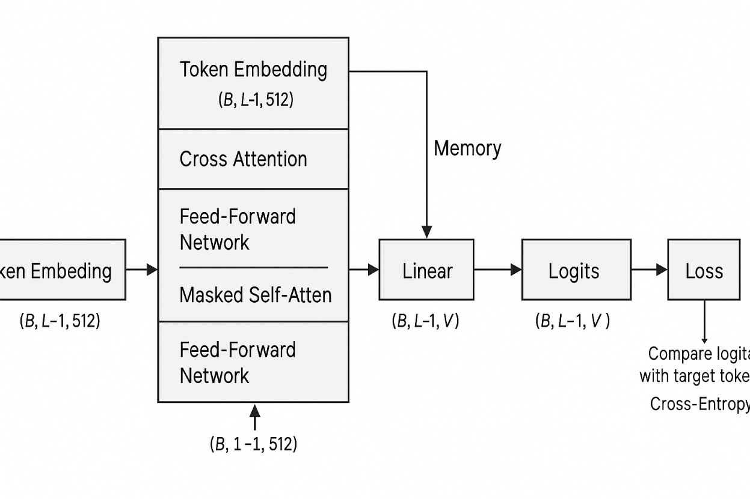
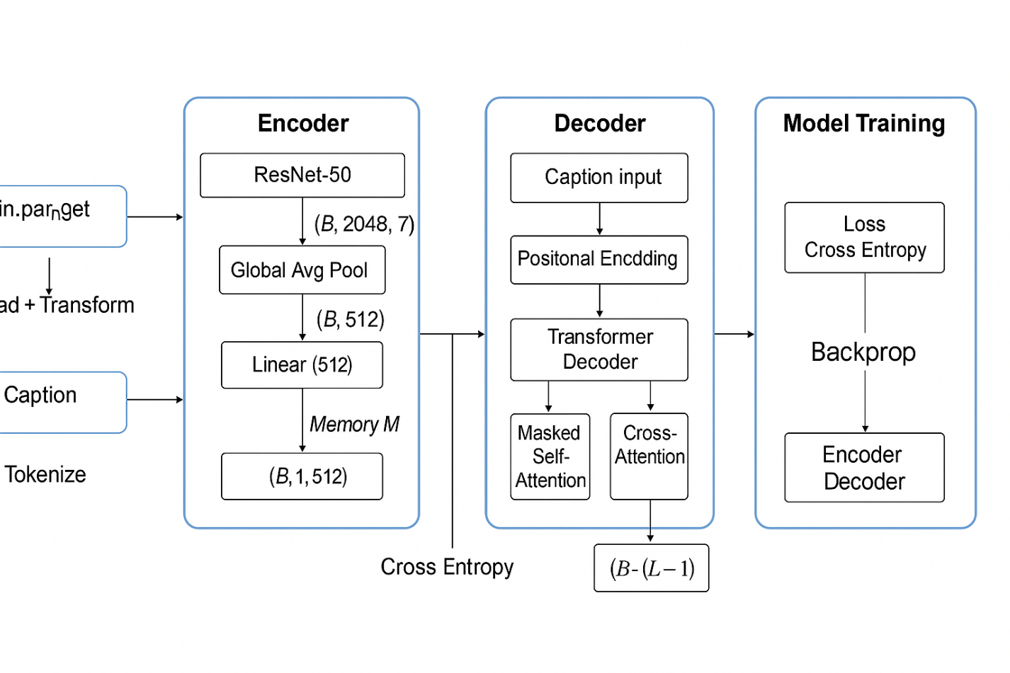

Model-1: What Goes Where? (Super Clear Version)
1. Data Ingestion (Model-1)
During data ingestion for Model-1, we load:
✔ Image
X_img : (B, 3, 224, 224)
✔ Metadata (categorical fields)
Example:
- gender
- masterCategory
- subCategory
- articleType
- brand
These are converted to IDs, then embedded:
gender_emb : (B, 16)
masterCategory_emb : (B, 32)
subCategory_emb : (B, 32)
articleType_emb : (B, 32)
brand_emb : (B, 32)
All embedded metadata vectors are concatenated:
metadata_vec : (B, D_meta) # ~140
✔ Caption (tokenized)
caption_tokens : (B, L)

❗ Correct Understanding of Model-1 (IMPORTANT!)
🔥 Encoder does NOT get only image.
It gets:
- Image (through MobileNetV2)
- Metadata embeddings (through embedding layers)
🔥 Decoder does NOT take metadata directly.
The decoder only takes caption tokens, just like baseline.
🔥 Image and metadata DO NOT multiply inside decoder.
They are fused before the decoder, inside the encoder block.

⭐ TRUE Architecture for Model-1
Step 1 — Encoder: Image + Metadata Fusion
1A. Image goes through MobileNetV2
MobileNetV2 → (B, 1280)
1B. Metadata Embeddings
All fields embedded → concatenated:
metadata_vec : (B, ~140)
1C. Concatenate image + metadata
concat = [image_vec ; metadata_vec]
concat shape = (B, 1280 + 140)
1D. Linear Fusion Layer
This turns combined vector into decoder memory:
fused_vec = Linear(concat) # → (B, 512)
1E. Unsqueeze to match decoder memory shape
memory M = fused_vec.unsqueeze(1)
M shape = (B, 1, 512)

🔥 This is the MOST IMPORTANT POINT:
❗ In Model-1, image + metadata are fused BEFORE the decoder.
The decoder receives a single fused memory vector that already contains:
- visual features
- metadata semantics
So:
🚫 The decoder does NOT take metadata
🚫 The decoder does NOT multiply image by metadata
The decoder only sees:
fused_memory : (B, 1, 512)
caption_input : (B, L-1, 512)

⭐ Step 2 — Decoder (Same as Baseline)
The decoder works identically to baseline:
- Takes caption tokens
- Uses masked self-attention
- Uses cross-attention over fused memory
- Predicts next word in caption
There is no separate metadata operation inside decoder.

⭐ Step 3 — Loss Computation and Backpropagation
We compare:
predicted_logits : (B, L-1, vocab_size)
target_tokens : (B, L-1)
Cross-entropy loss computed → gradient flows backward.
🔥 Where do gradients go?
- Decoder gets updated
- Fusion linear layer gets updated
- MobileNetV2 encoder gets updated
- Metadata embedding layers get updated
So training adjusts:
- how image is interpreted
- how metadata embeddings contribute
- how their fusion influences caption generation
- how decoder generates final tokens
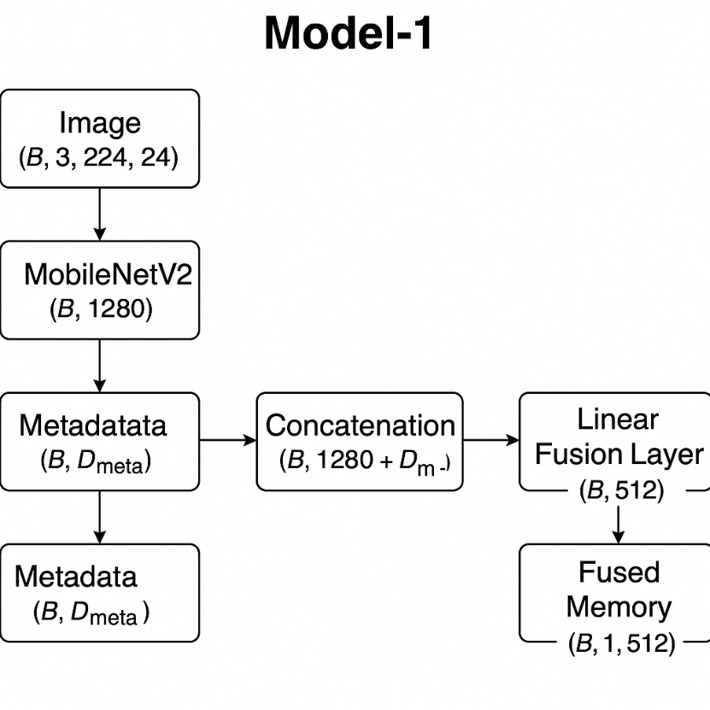

Baseline Model | Model-1
---------------- | -------------
Data Ingestion | Data Ingestion
Encoder | Image → MobileNet
Memory | Metadata Embedding
Decoder | Fusion Layer
Output | Decoder

